DSCI5350 Assignment-2 Satyasriharsha Buddha

Deliverables & requirements:  
You must provide screenshots of your solutions. All the tables that you create should have your  
EUID as suffix. And set the terminal title to your name. The submission should be a word  
document.

* Terminal title to my name is set already.
* The tables I created for assignment are suffixed with my EUID

Question-1

Correctly process the given data and store it in the hive display top 5 rows of the data

* The Store.csv file was imported to Desktop from Canvas
* The HDFS and hive shells were initiated

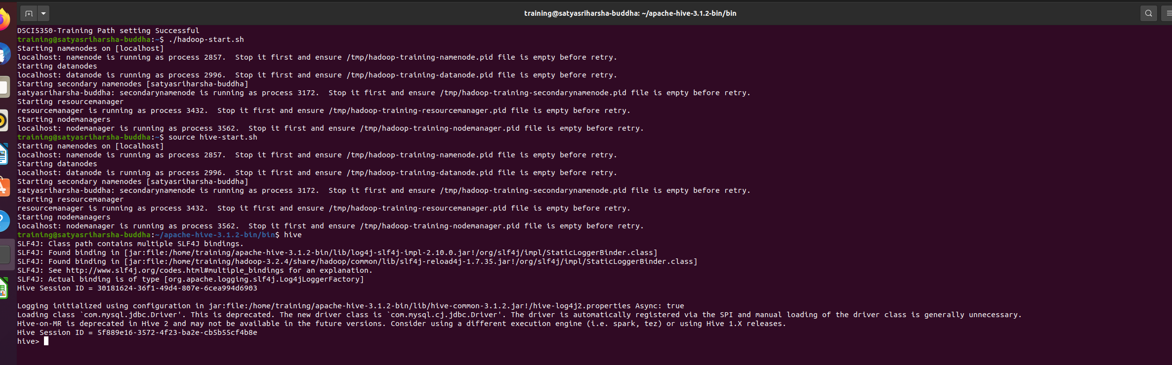

* Loading Store.Csv into hdfs using –put command

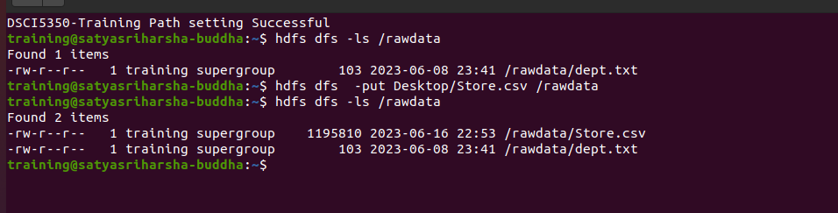

* Viewing the data in the store.csv file using –cat command

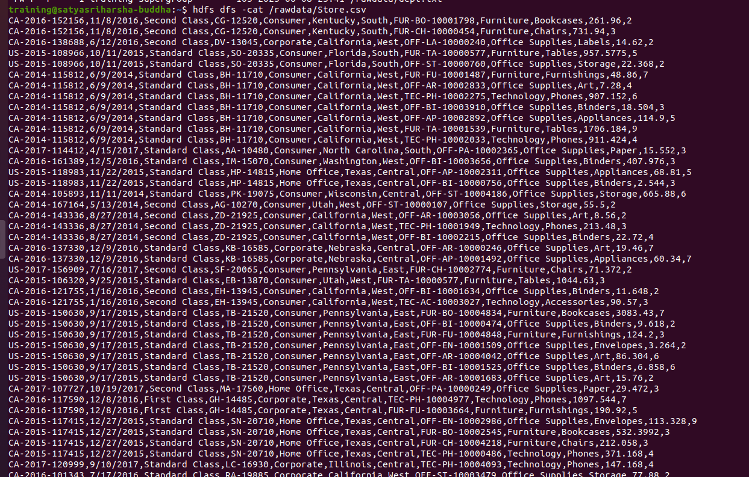

* Created a table in hive store_sb2020 and get top 5 records

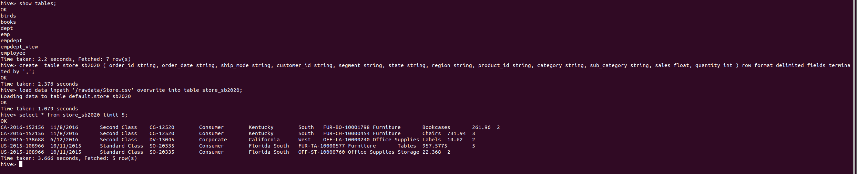

* Using the select count(*) command to get see if complete data is retrieved

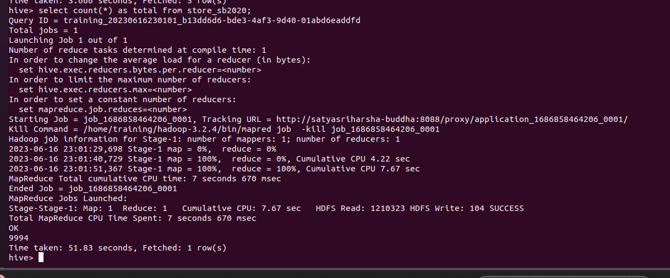

As 9994 rows were retrieved, we can say that complete data was loaded.

Question 2: Display details of highest Sales in each Category type (select top 2 only)

* SELECT * FROM ( SELECT *, ROW_NUMBER() OVER (PARTITION BY Category ORDER BY Sales DESC) AS row_num FROM store_sb2020 ) t WHERE row_num <= 2;

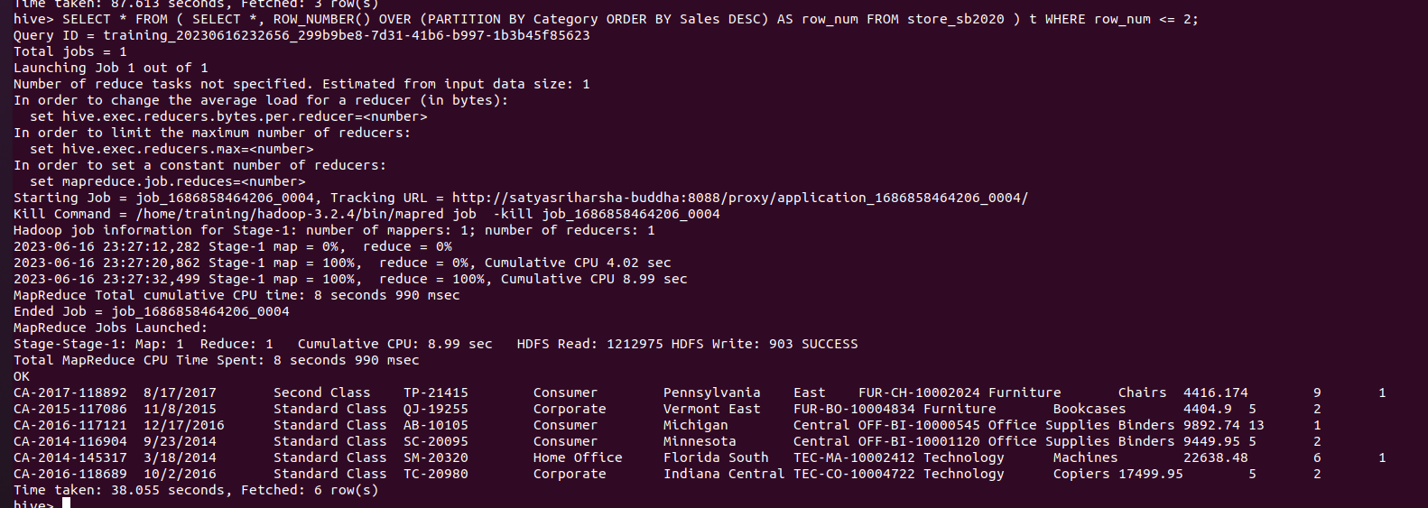

* We order by sales in descending order, and We use the ROW_NUMBER() function with the PARTITION BY clause to assign a row number to each row within its respective category, and then filters the result to only include rows with a row number less than or equal to 2.

Question 3: Display details of top 25% of sales for each region. (Must use ntile() function)

* select * from ( select *, ntile(4) over (partition by region order by sales desc) as quartile from store_sb2020 ) t where quartile = 1;

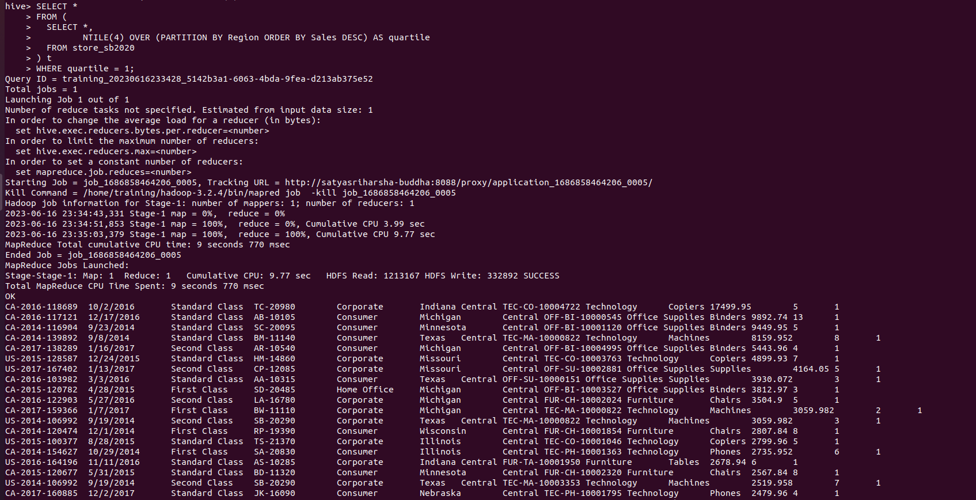

* We use the NTILE(4) function to assign a quartile number to each row within its respective region, with quartile 1 representing the top 25% of sales.

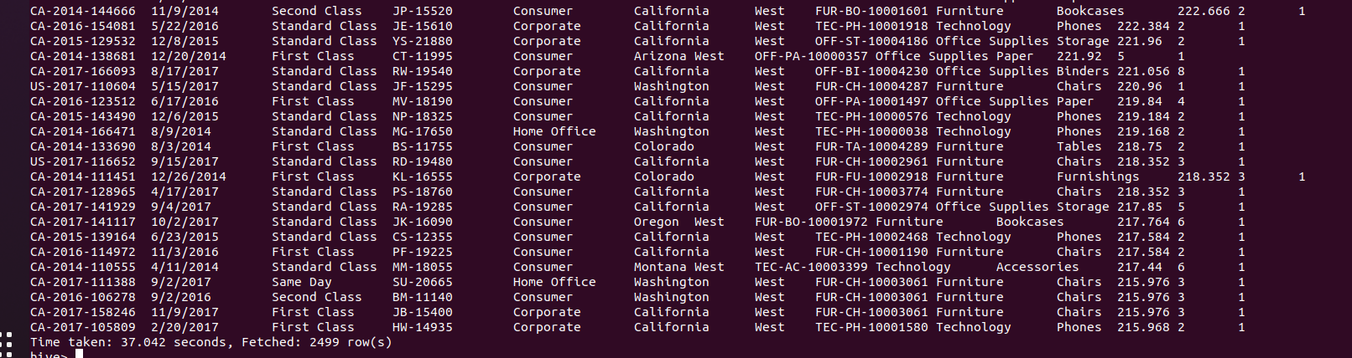

As we can see we retrieved 2499 Rows.

Question 4. Create a new Column Sales_Category to the table, based on Sales column as shown  
below. Calculate number of unique Products under each Sales_Category.  
Sales above 20000 High  
Sales above 10000 and below 20000 Medium  
Sales above 0 and below 10000 Low

* Created a new table named store_sb2020_new with new column Sales_catetgory



* insert into store_sb2020_new select order_id, order_date, ship_mode, customer_id, segment, state, region, product_id, category, sub_category, sales, quantity, case when sales > 20000 then 'High' when sales > 10000 and sales <= 20000 then 'Medium' when sales > 0 and sales <= 10000 then 'Low' end as sales_category from store_sb2020

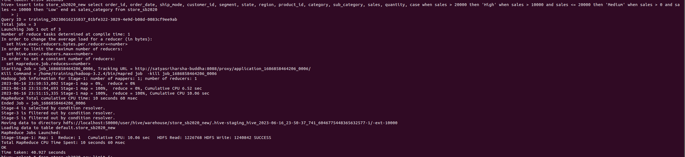

* As you can see we have new column and data
* Select * from store_sb2020_new limit 5;

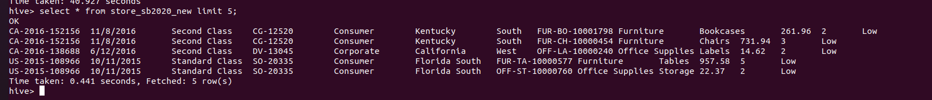

* SELECT Sales_Category, COUNT(DISTINCT Product_ID) AS Unique_Products FROM store_sb2020_new GROUP BY Sales_Category;

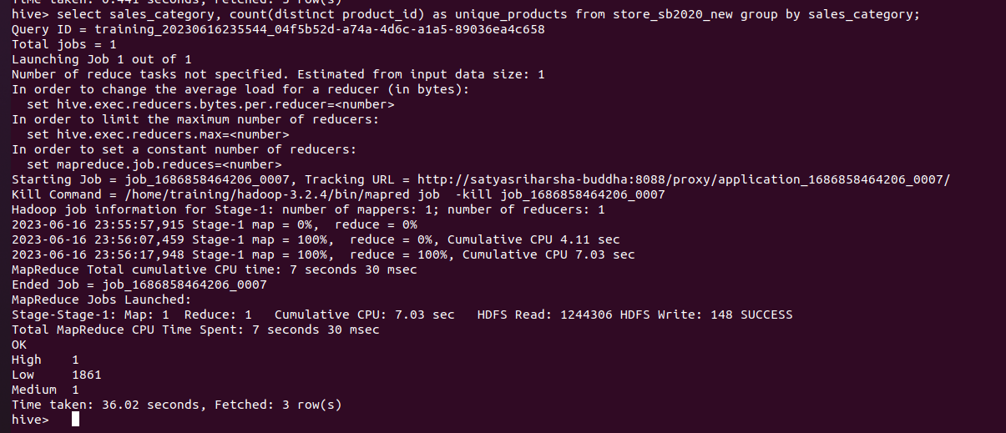

Question 5. Display Percent change in average sales across every year.

* The Current date format in order_date column is mm/dd/yyyy

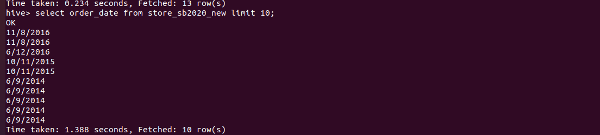

* Creating a new table store_sb2020_latest with new column Order_year for which year is extracted

Create table store_sb2020_latest as select *,year(fromunixtime(unix_timestamp(order_date,’MM/dd/yyyy’))) as order_year from store_sb2020_new;

* We are extrating year from order_date into a new column order_year

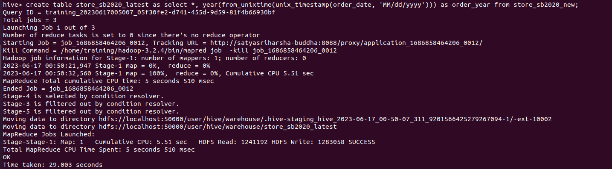

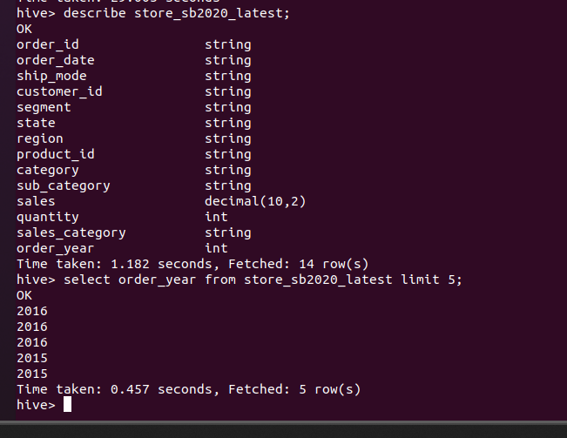

* As you can see the order_year is correctly loaded as per the top rows
* SELECT order_year, AVG(sales) AS average_sales, (AVG(sales) - LAG(AVG(sales), 1) OVER (ORDER BY order_year)) / LAG(AVG(sales), 1) OVER (ORDER BY order_year) * 100 AS percent_change FROM store_sb2020_latest GROUP BY order_year;

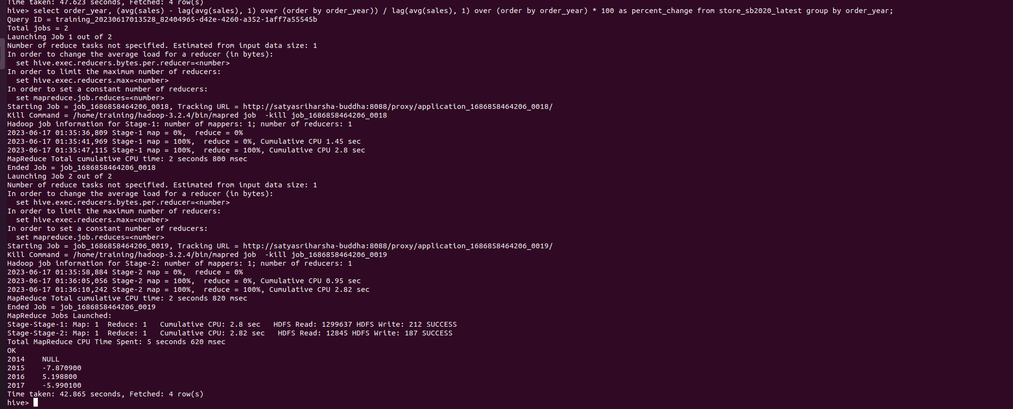

* The AVG function calculates the average sales for each year, and the LAG window function retrieves the previous year's average sales.
* The percent change is then calculated by subtracting the previous year's average sales from the current year's average sales, dividing it by the previous year's average sales, and multiplying by 100

References: https://cwiki.apache.org/confluence/display/hive/languagemanual+windowingandanalytics